# Task : creating a web app

# student: Omar Abdulrahim

# major: information systems (4)

# 

# staff allocation:

|  |  |  |
| --- | --- | --- |
| Team | Task | Duration (Weeks) |
| Alpha | Create UI | 1 - 3 |
| Alpha | Set up DB | 1 - 4 |
| Alpha | Implement Backend | 3 - 5 |
| Beta | Implement Frontend | 3 - 5 |
| Beta | Connect Frontend, Backend, DB | 5 - 7 |
| Gamma | Testing Software | 7 - 12 |

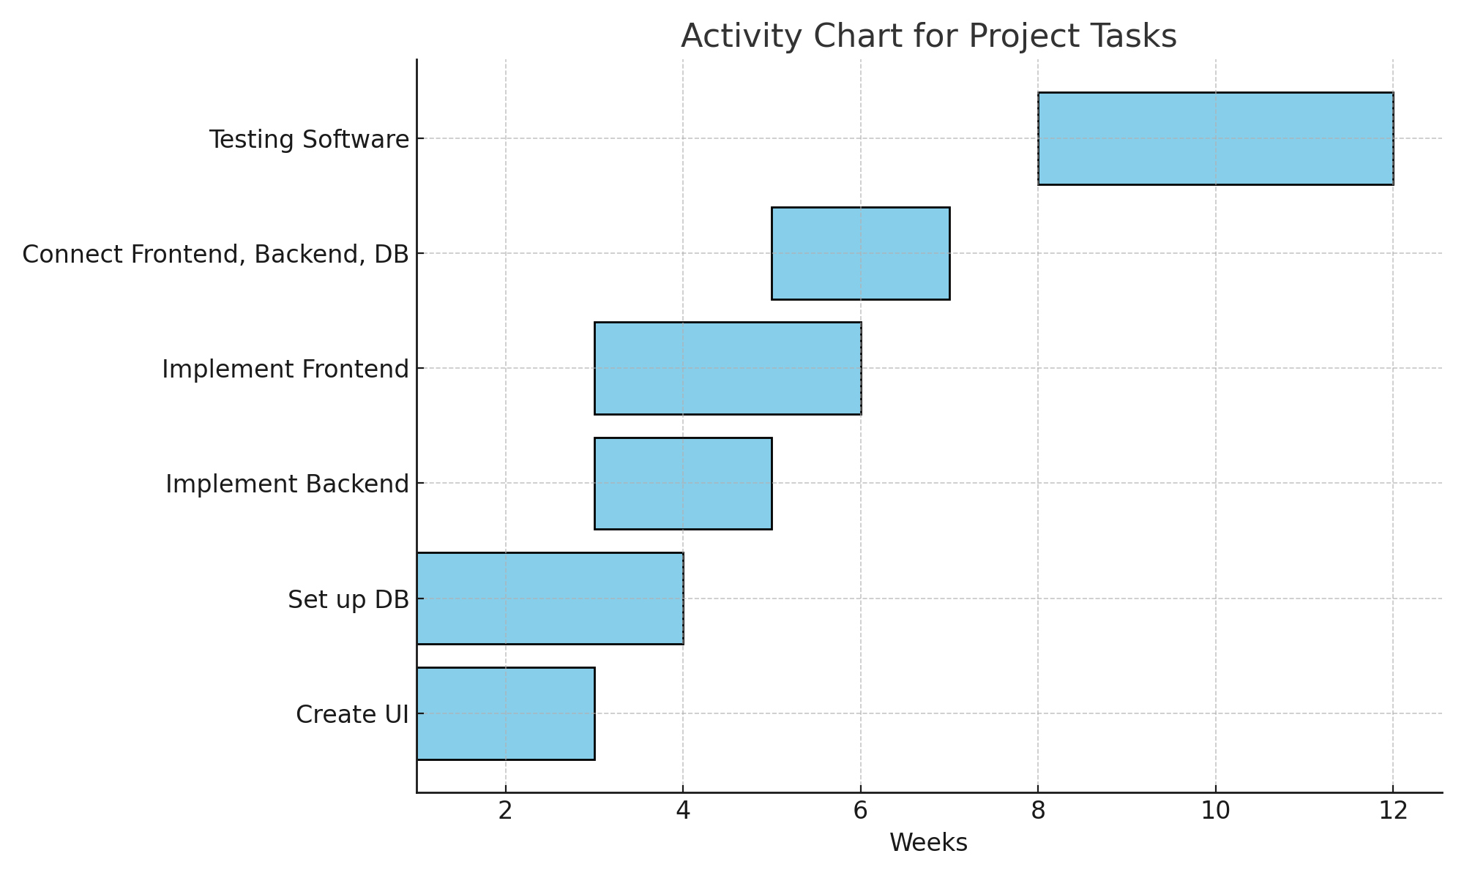Activity bar chart: